Warranty Procedure No. 1-5.2 Rev. 1.0
PACCAR WARRANTY FIELD PROCEDURE
Andrews Logistics LP | Maintenance Division
Policy Number | Policy Owner | Effective Date
1-5.2 Rev. 1.0 | David Reis, Vice President of Maintenance | May 2026

WHAT’S INSIDE
1 The Field Card — every warranty job, every time
2 Can we even claim this? The 4-gate check
3 STOP — jobs that need approval before you start
4 The repair story (Complaint • Cause • Correction)
5 Fault codes & diagnostics
6 Photos — what to shoot
7 The failed part — tag it, hold it
8 Time — punch it right
9 Submitting the claim (Warranty Manager)
10 Coverage Quick Reference — day cab & sleeper
11 Claim status cheat sheet
A Appendix — photo examples

Read it like this: technicians and foremen own sections 1–8 — the evidence is captured in the bay, while the truck is in front of you. The Warranty Manager owns section 9. Sections 10–11 are reference. If you only memorize one page, memorize the Field Card.

1. The Field Card
Every warranty repair, every truck, no exceptions. If any box is empty when the truck leaves, the repair is not a warranty claim — we eat the cost.
✓ | Capture | What “good” looks like
☐ | VIN + mileage + date | Exact chassis VIN, current odometer, and date of failure. Confirm the unit is in coverage before you start.
☐ | Repair story (CCC) | Complaint, Cause, Correction in plain language (section 4). Not “faulty” — say what failed and why.
☐ | Fault codes / diagnostics | Every code pulled, exit steps, measured values vs. spec, repair-verification result (section 5).
☐ | Photos | Clear shot of the failure + overall vehicle, plus any special shots for that part (section 6).
☐ | Time punches | Clock on/off each warranty operation. Electronic only. Warranty time separate from other work (section 8).
☐ | Failed part tagged | Defective Material Tag filled out, part bagged/staged in the warranty hold area (section 7).
☐ | Approvals / escalation | If the job hits a STOP trigger (over-$3K structural, 10+hr paint, chassis mod), get the PA number first. If diagnosis stalls, escalate to your manager + RDS — you do not open the TCS case yourself (section 3).

THE ONE-LINE RULE
If you can’t prove it, it didn’t happen. PACCAR pays on evidence, not on your word. The package is built while the truck is in the bay — not from memory three weeks later.

2. Can We Even Claim This? — The 4-Gate Check
Run these four gates at write-up, before any real labor goes in. A failed gate means route the job to a Peterbilt dealer or handle it as non-warranty — don’t burn labor we can’t recover.
# | Gate | If it fails…
1 | In coverage? | Check the VIN’s age/mileage and the failed part against coverage (section 10, and verify in PRWS). Out of term → not warranty.
2 | Right tier? | Component R&R and driveline R&R = in-house OK. Non-engine MAJOR components → Peterbilt dealer.
3 | Engine internal? | We do NOT do internal engine work in-house. Any internal engine repair → Peterbilt dealer. Don’t start it here.
4 | Approval first? | On the STOP list (section 3)? Get the PA / TCS case number BEFORE you start. Work started before approval is not paid.

3. STOP — Get Approval Before You Start
These jobs require an approval number on the claim. No approval = automatic denial, no matter how good the repair was. When in doubt, call the Warranty Manager before you turn a wrench.
DO NOT START THESE WITHOUT AN APPROVAL NUMBER
• Cab / hood / sleeper / sheet-metal / structural repair over $3,000 (parts + labor) → Warranty PA.
• Paint repair of 10+ labor hours → Paint PA with BEFORE pictures.
• Any internal engine repair → we don’t do these in-house. Route the unit to a Peterbilt dealer.
• Any chassis modification → before-and-after photos + a TCS365 case (opened via escalation, below).

3.1 When diagnosis stalls — the RDS / TCS escalation
If you cross 3 hours of troubleshooting with no clear diagnostic path (8 hours if a DTM is already involved) and a TCS365 case is what stands between you and recovery, do not keep grinding and do not open the case yourself. Stop and escalate:
- Get with your manager — right away, not at the end of the shift.
- Loop in the RDS team (Andrews Remote Diagnostic Support) to drive the diagnosis.
- A Manager, RDS, or Director opens the TCS365 case and records the case number on the repair. Technicians never open the TCS case.
Diagnostic time with no repair is not reimbursed — the point of escalating is a fast, clear path to a warrantable repair.

4. The 3 C’s — Complaint, Cause, Correction
In FleetRock every task carries the 3 C’s, and they are the single biggest reason a claim gets paid or returned. Two of them are locked dropdowns — and the code you pick decides whether the line reads as a warranty repair or a self-inflicted one.
The 3 C’s | How you enter it | Get it right
Complaint | Free text — you type it | The driver/operator’s reported symptom in plain words: “check engine light”, “coolant leak”, “won’t go into gear”.
Cause | Locked code — you pick | Choose a code that names a genuine DEFECT/FAILURE. Avoid codes that mean damage, contamination, abuse, wear, or no-repair (table below).
Correction | Locked code — you pick | Choose a code that names a real REPAIR action — repaired, replaced, rebuilt. Not cleaned, inspected, adjusted, or “not required.”

THE CODE MUST MATCH THE TRUTH
Pick the code that honestly describes the failure. You don’t dress up a wear or damage failure as “05 Defect” to force a claim. If the real cause is Damage, Contaminated, or Abuse, it isn’t a warranty repair — don’t submit it as one. The skill is classifying correctly, not gaming the dropdown.

4.1 Cause codes — what to use for recovery
USE for warranty recovery | Means
05 – Defect, Failure | The primary warranty cause — the part failed on its own.
03 – Cracked | Defect-driven crack (not impact/abuse).
09 – Leaking | Component leaking from a defect.
87 – Seized | Bearing/assembly seized — internal failure.
88 – Porosity | Casting porosity — a manufacturing defect.
12 – Recall | Recall / campaign work only.

NEVER use for recovery | Why it kills the claim
01 – Abuse | Operator-caused — excluded.
02 – Contaminated | External/maintenance — excluded.
04 – Damage | Accident/external — excluded.
86 – Gelled Fuel | Environmental/operator — excluded.
00 – Unknown | No identified cause = no claim.
06 Evaluate / 07 Inspection / 13 PM Inspection | No defect, no repair — not reimbursable.
10 – Out of Adjustment | Adjustment, not a defect (excluded after 25k mi).
14 – Worn | Normal wear — excluded.

4.2 Correction codes — what to use for recovery
USE for warranty recovery | NEVER use for recovery
07 – Repaired | 02 – Cleaned
08 – Replaced | 03 – Inspected
06 – Rebuilt | 04 – Not Required
01 – Adjusted | 00 – Unknown
05 – Performed | 10 – Travel · 11 – Training
93 – Weld/Fabricate | 13 – PM Inspection

Watch the limits: Adjusted is warrantable only in the early-life window — PACCAR treats most adjustments as non-warrantable after 25,000 mi. Weld/Fabricate on a structural part over $3,000 needs a Warranty PA first (section 3). Performed must be backed by a specific repair story in the RO notes; on its own it explains nothing.

4.3 Write the repair story in the RO notes
The codes classify the job; the written repair story proves it — and it has to live where PACCAR can see it.
RO NOTES, NOT PRIVATE NOTES
Put the full repair story in the RO notes — the official notes that carry to the claim. Never in private / internal notes. A story buried in private notes is invisible to the analyst and does not support the claim. Use Correction code 09 – See RO Comments to point the reviewer to it.
Follow the same Complaint → Cause → Correction logic in plain language: diagnostics, fault codes, tests, measured values, and the verification result.

Acceptable repair story includes
- A summary tied to the customer complaint
- Diagnostics performed (fault code / exit step) and the fault found
- A condensed version of the repair that corrected the fault
- TCS direction summarized (if a case was opened)
- Non-time justified — under 3 hrs justify in the story; over 3 hrs use the Non-Standard Time Worksheet
- Progressive damage justified, if any

Unacceptable — these get the claim returned
- Just pasting the technician’s raw notes
- Filler that isn’t about the repair (“walked to lot, looked for keys…”)
- Run-on sentences, mystery abbreviations
- Complaint/Cause/Correction not clearly identified
- Non-time or progressive damage not justified

Example — done right (electrical)
ACCEPTABLE
Complaint: Check engine light on
Cause: Open circuit in aftertreatment harness
Correction: Troubleshot P3763, exit step 4B. Measured DPF differential pressure sensor pins, found 0V supply (out of spec). Traced circuit through PCI connector D; resistance/continuity isolated open to aftertreatment harness. Removed inner fender, found harness rubbing under Primary Chassis Module; open in wire VIO3213-1. Repaired and re-wrapped harness, reconnected, ran verification — no codes returned. **non-time: inspect/trace (0.5), repair harness (0.5).

Compare: “Aftertreatment harness faulty, replaced.” — no codes, no diagnosis, no cause. That version gets returned and your payment stalls.

5. Fault Codes & Diagnostics
PACCAR adjudicates engine and electrical claims on the diagnostic trail. Capture it as you go — you can’t recreate a live reading after the truck rolls.
- Pull and record every active and stored fault code, with the exit step you followed (e.g., P3763 – Exit Step 4B).
- Use DAVIE / ESA for the guided diagnostics; record measured values and the in-spec/out-of-spec result for each test.
- Note any software updates by from/to version (e.g., updated SW from 5569989 to 5570055).
- Run and record the repair-verification cycle / regen / road test where the procedure calls for it — “no codes returned” closes the loop.
- Diagnostic time with no repair is not paid. If you cross 3 hours with no clear path, STOP and escalate to your manager + RDS — don’t open the TCS case yourself (section 3.1).

6. Photos — What to Shoot
EVERY CLAIM, MINIMUM
1) A clear, in-focus photo of the failure / damage — the defect must be obvious.
2) An overall photo of the vehicle.
Mark the area of concern (paint, tape, or zip tie) so the defect is unmistakable. Blurry or “where is it?” photos delay or deny the claim.

Common items carry extra shots. This is the working subset for day cab/sleeper repairs; the PACCAR Photo Requirements Quick Reference is the full authority, and analysts may request more on any claim.
Item | Shoot | Special requirement
Batteries (all) | Failure + overall vehicle | Midtronics test results
Injectors | Failure + the injectors | Label to identify injectors 1–6
Alternator / Starter | Failure | Supplier ID marking, part #, serial #
Harnesses | Failure + before/after | Part # + serial #
Axles / Driveline | Failure + before/after + overall | —
Air leaks | Failure + before/after | Per Warranty Manual §1.7.1 criteria
Fluid leak (any) | Failure (source of leak) | —
Turbocharger | Failure | See Bulletin E212
Oil pan | Failure | See Bulletin E296
DEF / fuel tank | Failure + overall (+ cap) | —
Frame rail / crossmembers / gussets | Failure + before/after + overall | Part #, serial #, supplier code
Hood | Failure + before/after + overall | Part #, serial #
HVAC (control/module/blower) | Failure + before/after | Front & back of control head
Paint issues | Failure + before/after + overall | Paint PA if 10+ hrs (before pics)
Modifications | Before + after | TCS365 case number
Progressive damage | Failure | Justify in the repair story

Not required: odometer, VIN door label, or VIN plate photos — except capture the odometer when mileage lands on an exact round number (e.g., 100,000), since that’s unusual and may be questioned.

7. The Failed Part — Tag It, Hold It
The Warranty Manager is responsible for parts, but the field makes or breaks it the moment the part comes off the truck.
- Tag immediately with the Peterbilt Warranty Defective Material Tag — chassis #, RO #, part #, and (once filed) the Claim Unit (CU) #.
- Stage in the warranty hold area, secure and protected from weather/deterioration. Sort by last digit of VIN or RO # so it can be found fast.
- Hold 30 days after the CU is paid, unless a Return Authorization (RA) is issued sooner.
- Mark the defect on the part (paint/tape/zip tie). Don’t disassemble it. Drain and plug anything with fluid.
PARTS THAT KILL CLAIMS
A part that shows up rusted, broken, or damaged from poor storage or shipping is denied. A returned part with a blank or unreadable tag is scrapped — and the claim dies with it.

8. Time — Punch It Right
- Every technician on a warranty repair records electronic time punches — date and time, on and off.
- Each warranty operation on the RO shows its own punches. If the job is interrupted, record stop and start.
- Warranty time is recorded separately from internal and customer-pay work. One RO at a time per tech.
- Record in hours and tenths. Only the actual time clocked is paid — if SRT says 2.0 but you clocked 1.5, the claim pays 1.5.
- Handwritten time is not accepted. Electronic printouts only.

9. Submitting the Claim — Warranty Manager
Two systems, every claim: PRWS is the claim of record to PACCAR; FleetRock is our internal tracking so nothing falls through the cracks and the command center stays current. File in PRWS first, then mirror to FleetRock the same day.

9.1 PRWS — the claim of record
- Verify coverage for the VIN (base and any extended) and confirm the failed component is in term.
- Select the correct claim type and category — this cannot be changed after filing. Wrong category = denied + refile (section 9.3).
- Enter the repair story (CCC), the RO closed date (≤ 5 days from last punch), and any PA / TCS365 case number.
- Attach the evidence: photos, diagnostic captures, time printouts, and before/after shots where required.
- File within the deadline: ≤ 45 days from the date of failure (internal target ≤ 15 days from repair complete). Campaigns ≤ 14 days.
- Record the failed-part tag and hold location; complete the RA and enter ship date + tracking number if a return is requested.

9.2 FleetRock — the repair-order workflow
FleetRock is where the repair and the warranty flag are captured, and it feeds the command center. Follow the platform’s own RO flow so nothing is missed:

Create the RO
- Repair Orders → Create Repair Order. Select the Unit # (VIN) and the correct customer/vendor, then tap Create.

Add the task (one per failure / system)
- Add Task → select the System Code and System-Component Code for the failed assembly.
- Enter the 3 C’s: Complaint (plain text), then a warranty-valid Cause code and Correction code (section 4).
- Write the repair story in the RO notes — the official notes that carry to the claim, not private notes (section 4.3).
- Assign the task to the technician and select the Labor Type (rate and tax pull from the rate card).
- Set Warranty Claim = Yes, then check Create Claim so FleetRock generates the warranty-claim record — not just the savings figure.
- Add Labor Hours using the Task Timer (ON/OFF) so logged time matches the punches. If multiple techs work the task, use Split Task; Mark Finished when the task is done.

Add parts
- Add Part → select System Code and Part (or “Add new part” if it isn’t in inventory). Set Warranty Claim = Yes and check Create Claim. Enter Quantity (tires require a Position).

Start & finish
- Start Repair Order → set the Expected Finish date → Update.
- Finish Repair Order once at least one task is complete. The RO moves Created → Started → (Waiting, if over the approval threshold) → Finished, then Invoiced / Paid. The finish date records automatically.

Tracking link: after filing in PRWS, record the PRWS Claim Unit (CU) #, claim category, amount requested, date of failure, the failure-date + 45-day deadline, and the failed-part hold location / tag # against the RO so the command center shows live status.

9.3 Pick the right claim category
Assembly | Make / Type | Category
Transmission / Clutch | PACCAR | PACCAR Transmission
Steer Axle | PACCAR | PACCAR Steer Axle
Rear Axle | PACCAR | PACCAR Rear Axle
Transmission / Clutch | Eaton, Fuller | Truck
Steer / Rear Axle | Meritor, Dana, Hendrickson | Truck
Brakes | Bendix, Meritor | Truck
Steering Gears | Sheppard, TRW | Truck
Structural | Cab, Hood, Fenders, Sleeper | Truck

10. Coverage Quick Reference — Day Cab & Sleeper (Class 8)
Always verify the specific unit in PRWS. Terms below are the standard Class 8 baseline; whichever limit (months OR miles) is reached first ends coverage.
BASIC / STANDARD coverage (comes with the truck)
Component | Standard term (whichever comes first)
Standard Vehicle (basic) | 12 mo / 100,000 mi
Severe Service vehicle | 12 mo / 50,000 mi
Base Emissions – CARB | 60 mo / 350,000 mi
Base Emissions – EPA / ECCC | 60 mo / 100,000 mi
PACCAR MX engine (base) | 24 mo / 250,000 mi / 6,250 hr
Engine major components | 60 mo / 500,000 mi / 12,500 hr
Vehicle major components | 36 mo / 300,000 mi
PACCAR front axles | 60 mo / 750,000 mi
Front axles – Meritor / Dana | 36 mo / 300,000 mi
Rear axles – PACCAR 40k (line haul) | 60 mo / 750,000 mi
Rear axles – PACCAR 40k (regional / P&D) | 24 mo / Unlimited
Rear axles – Meritor / Dana | 36 mo / 300,000 mi
PACCAR clutch | 36 mo / 350,000 mi
PACCAR transmission – TX-12 / TX-18 | 60 mo / 750,000 mi
Transmission – TX-12/18 PRO (std duty) | 36 mo / 300,000 mi
Transmissions – Eaton automated / manual | 36 mo / 300,000 mi
Brakes – Bendix / Meritor | 36 mo / 300,000 mi
Steering gears – Sheppard / TRW | 36 mo / 300,000 mi
PACCAR alternator & starter | 36 mo / 350,000 mi
Frame, rails, gussets, crossmembers, corrosion | 60 mo / 500,000 mi
Structural – cab / hood / half fenders | 36 mo / 300,000 mi
Structural – sleeper | 36 mo / 300,000 mi
Cab / hood paint | 12 mo / 100,000 mi
Sleeper paint | 12 mo / 100,000 mi
SmartLINQ | 24 mo / Unlimited
PACCAR batteries | 12 mo / 100,000 mi

EXTENDED coverage (the agreement we purchased)
We carry an extended warranty of 5 years / 500,000 miles. It applies only to the units it was purchased on and only to the components it covers — confirm per VIN in PRWS before relying on it.
Extended coverage | Term (whichever comes first)
Purchased extended warranty | 5 years / 500,000 miles

NOT WARRANTED (common denials)
Wear items & consumables — antifreeze, lubricants, bulbs, fuses, wiper blades, filters, fire extinguishers, chains, kits, tools.
Normal wear, storage deterioration, tire balance, alignments, upholstery; metallic chassis (frame) paint.
Damage from accident, misuse, neglect, improper/inadequate maintenance, or engine overheat.
Adjustments (vibrations, squeaks, minor leaks/noises) after 25,000 mi / 40,000 km — treated as use, not defect.
Accessories, wheels, pintle hooks, engine brakes — warranted by their own makers, not PACCAR.

11. Claim Status Cheat Sheet (PRWS)
Mirror these into FleetRock so the command center shows live status. The ones that need YOUR action are flagged.
Status | What it means / your move
Open – ManualReview | Submitted, waiting on a PACCAR analyst. No action.
Open – Hold | A PACCAR user is reviewing. No action.
Pending – DealerAction | ACTION: PACCAR wants more attachments. Respond fast — the clock is unforgiving.
Denied – OpenAppeal | ACTION: returned for clarification/adjustments/attachments. Fix and resubmit.
Pending – PartsReturn | ACTION: RA issued — ship the tagged part, enter ship date + tracking on the CU.
Approved – PendingPartReturn | ACTION: conditionally approved; complete the part return (RA) to close it out.
Resolved – Approved | Paid in full. Close in FleetRock.
Resolved – ApprovedAdjusted | Partially approved — review the adjustment; appeal if wrong.
Resolved – Denied | Denied. Root-cause it; appeal within policy if supportable.
Resolved – Chargeback | A previously paid claim was reversed — investigate immediately.

Appendix A — Photo Examples
Real examples of a claim-ready photo, taken from the PACCAR Warranty Procedure Manual. Match these in the bay. Every shot must be in focus, well-lit, and have the defect marked (paint, tape, or zip tie) so it is unmistakable.
EVERY CLAIM, MINIMUM
A clear photo of the failure/damage + an overall photo of the vehicle. Special cases: batteries need the tester (DSS/Midtronics) result; injectors must be labeled 1–6; structural parts need part #, serial #, and supplier markings.

1. Battery claim — capture the tester result
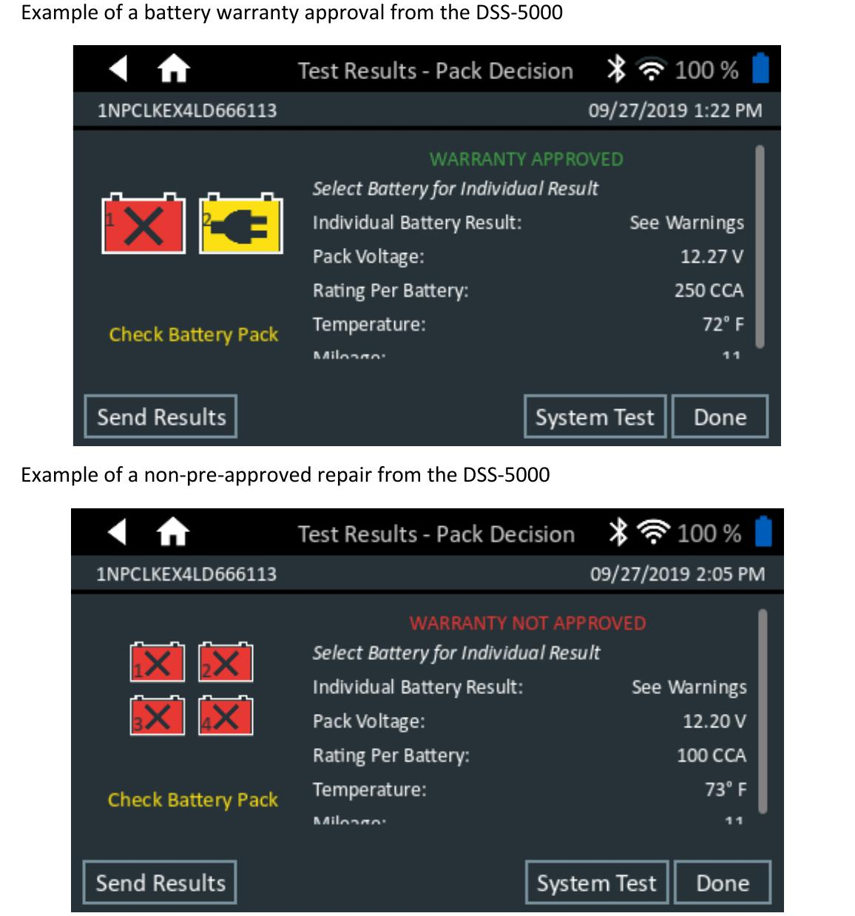
Batteries: send the DSS-5000 pack-decision screen. Top = WARRANTY APPROVED; bottom = NOT APPROVED. The on-screen result is the evidence — a photo of the battery alone is not.

2. Supplier part ID — prove it’s the right brand
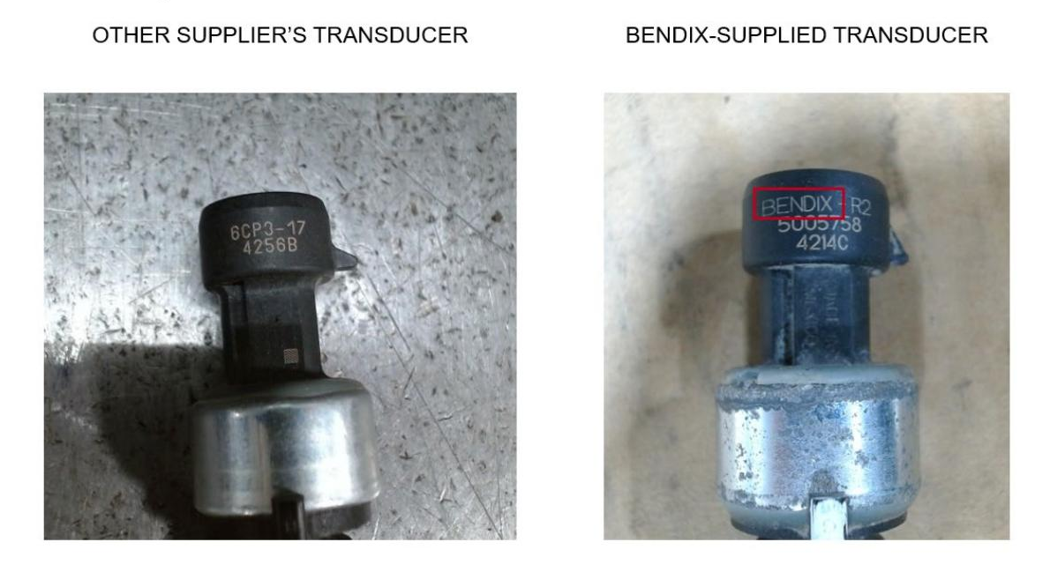
Supplier parts (e.g., Bendix): photograph the supplier markings before return. Left is another supplier’s part (will be denied); right is genuine Bendix. Wrong-brand or unlabeled parts get scrapped.

3. Fluid leak — show the origin, not a close-up
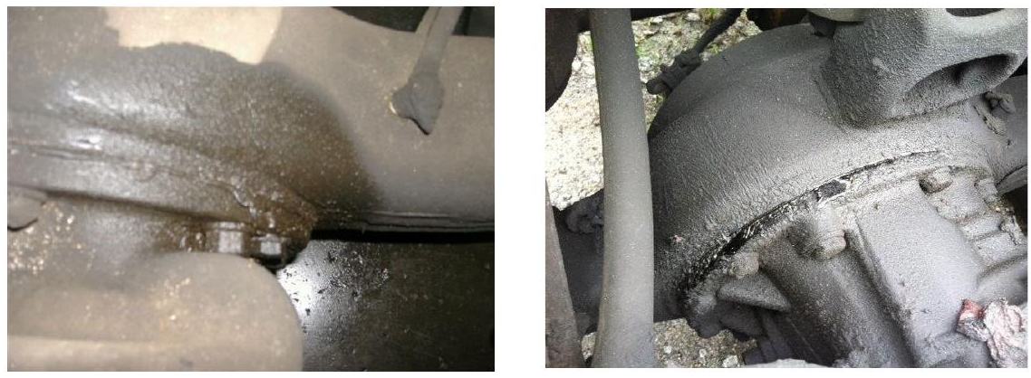
Axle / housing leaks (e.g., Dana): show the overhauled axle and the origin of the leak (left). A tight close-up (right) is NOT acceptable — the analyst can’t tell where the leak starts.

Source: examples from the PACCAR Warranty Procedure Manual (v2026.4). Build your own shop photo library here — a good example beats a paragraph of instructions.

Companion documents: Warranty Policy 1-5.1 • PACCAR Warranty Procedure Manual v2026.4
This framework will be reused for Thermo King, tires, and Polar as separate manuals.

